SQL AND HTML JOINING

SAMEERA

MY SQL OPENING

STEP 1:

OUTPUT:

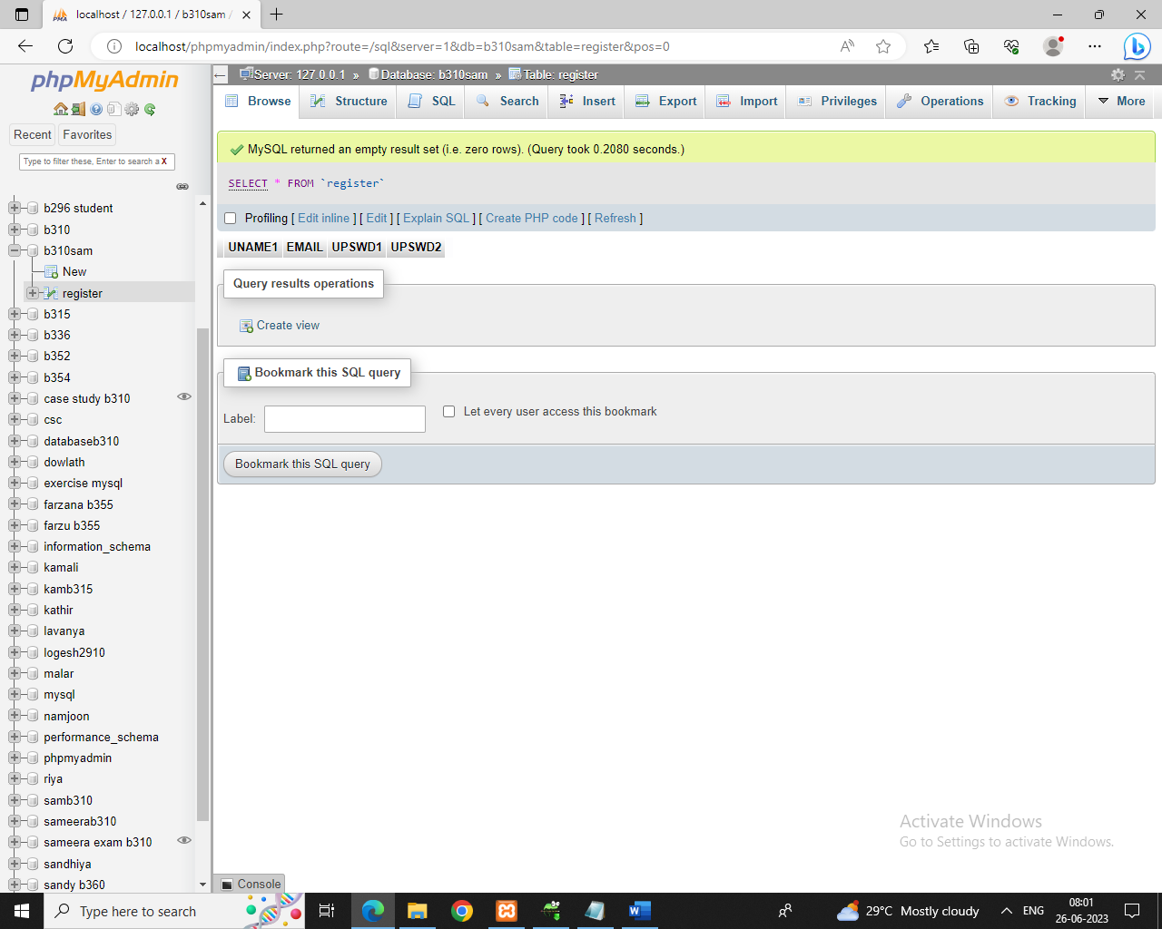

TABLE CREATION

INPUT & OUTPUT:

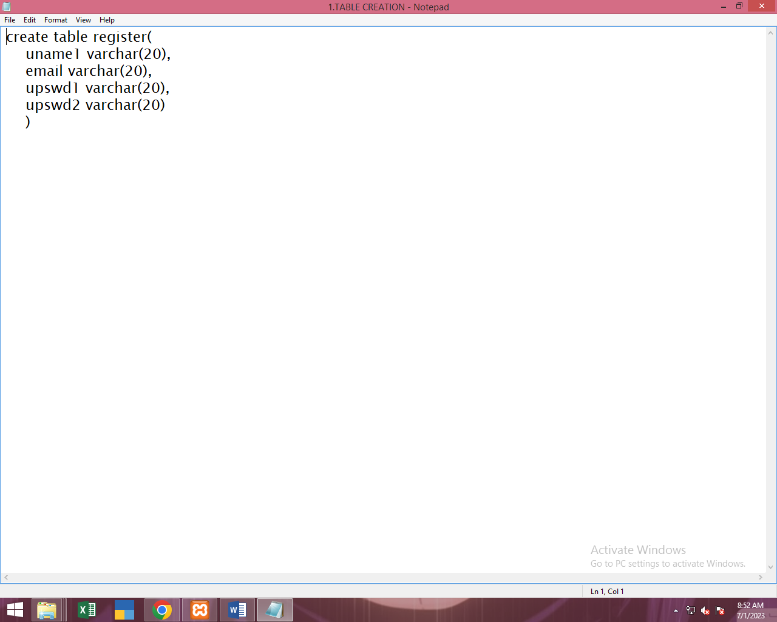

2.INDEX

INPUT& OUTPUT:

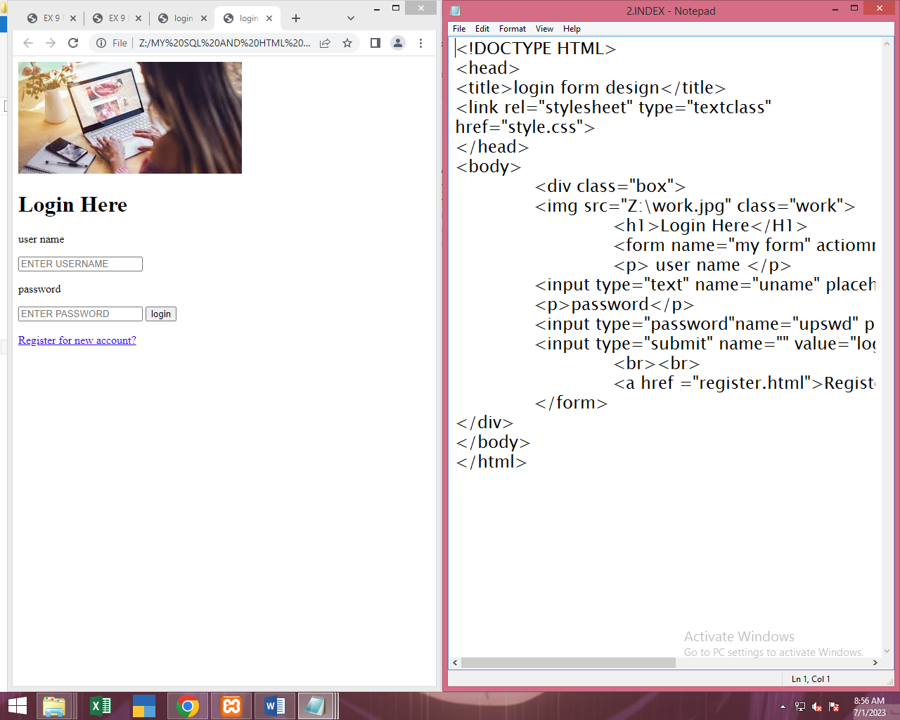

3.REGISTER.HTML

INPUT & OUTPUT:

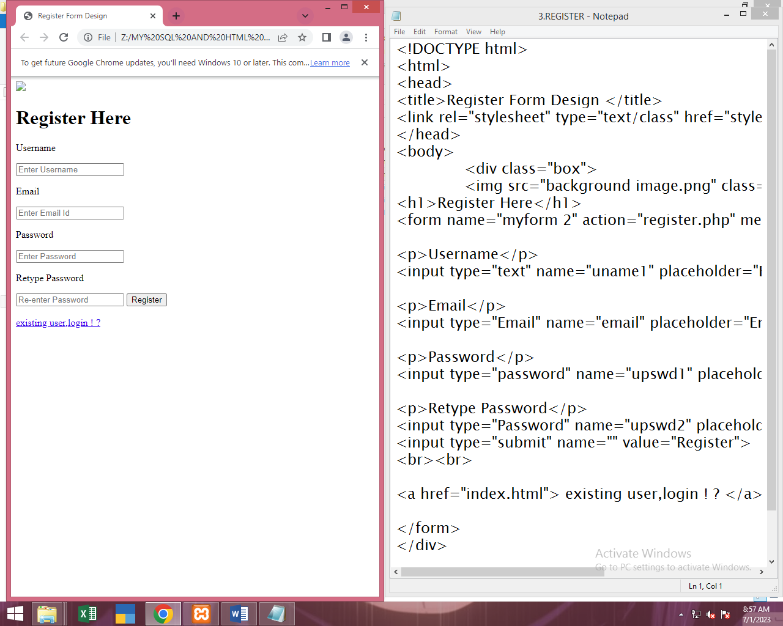

4.LOGIN.PHP

INPUT & OUTPUT:

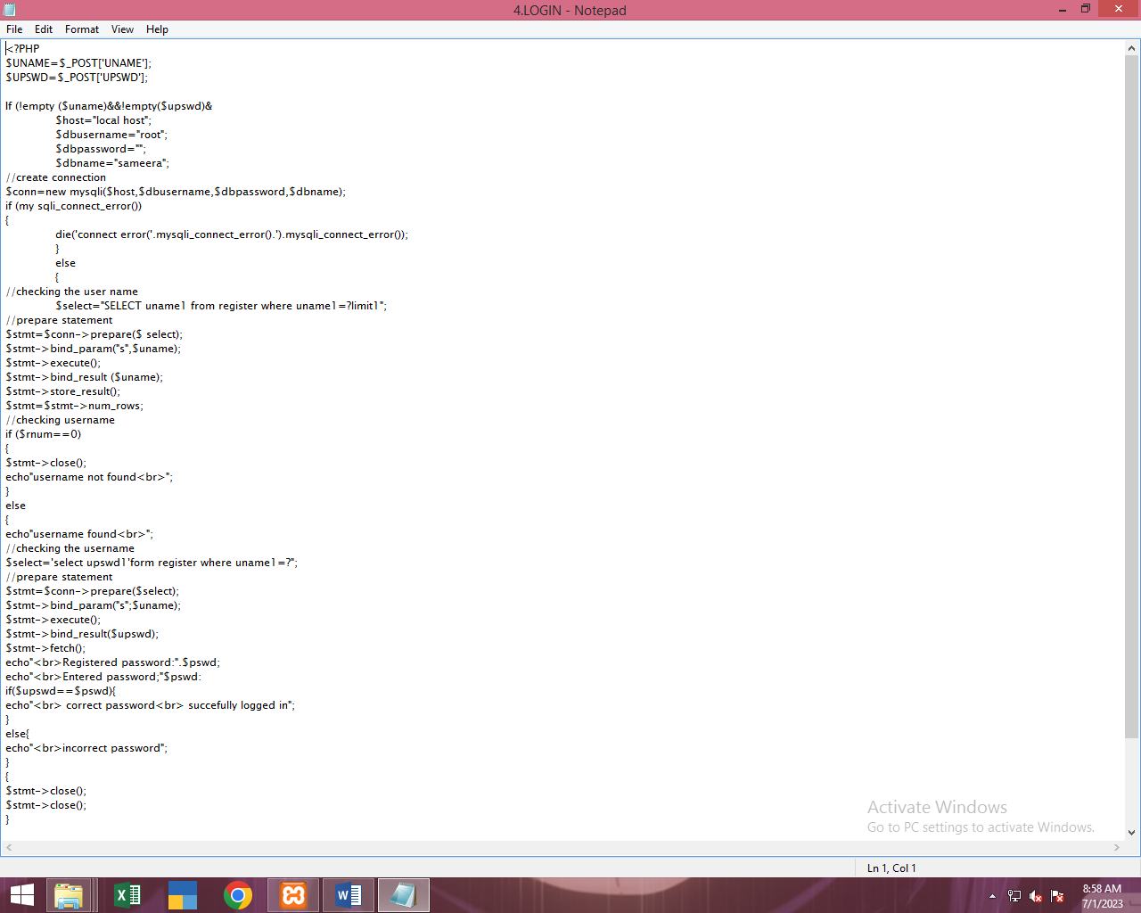

5.REGISTER.PHP

INPUT & OUTPUT:

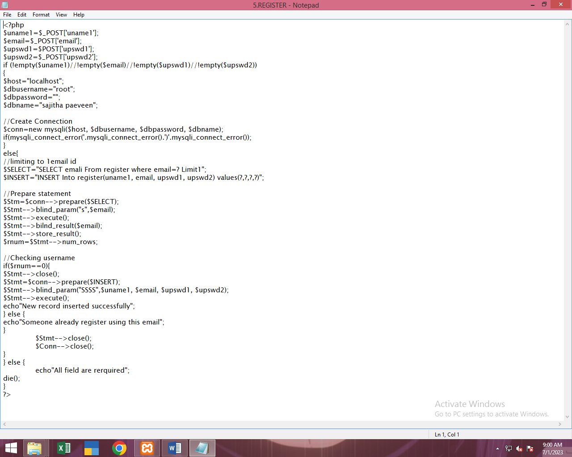

6.STYLE CSS

INPUT & OUTPUT:

